**Miró Quartet**

Beethoven: Opus 74, “Harp” and Opus 95, “Serioso” (MQM 2880-2)

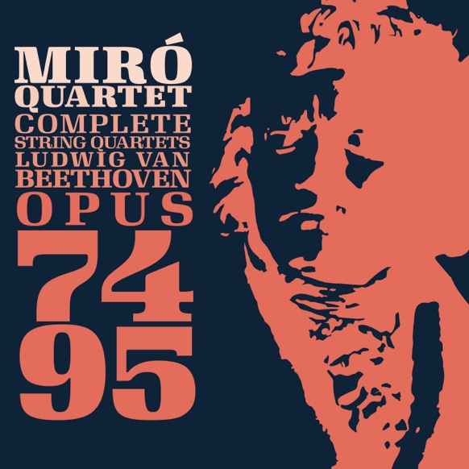

**Beethoven the Idealist, Beethoven the Expressionist**

The year 1809 marked an important change in Beethoven’s life: he was awarded a perpetual annuity by three wealthy patrons (Archduke Rudolf, Princes Lichky and Lobkowitz), so he would no longer have to live month-to-month solely off his commissions. In a very real sense, he had “arrived”. His status as the leading Viennese composer of his day had already been firmly established in the European cultural scene, and now as he neared forty, Beethoven had hopes for a calmer life: he even began looking seriously for a wife.

The fair hopes of this year were quickly dashed by the invasion of Vienna by the French that May, and the destruction and hardship they brought with them. Beethoven reportedly spent much of the bombardment with his head wrapped in a pillow in his brother’s cellar to protect what remained of his hearing. His no longer robust general health was shaken by the experience, and once it was all over and Vienna fell, he wrote absolutely no music for the next three months. When he did begin writing again, it was with the familiar and intimate form of the string quartet, in the form of Opus 74, “the Harp”. This piece can be seen as an attempt to return to normalcy, the recapturing of a happy dream; the form and length are very similar to the three Opus 59s of a few years previous, yet the general mood is more warm and gentle than these more heroic pieces. This Beethoven no longer has something to prove to his public, but for the first time in the string quartets his main goal seems rather to bring a dream into being, a dream for something better into our harsh world. Grace and playfulness (especially the harp-like plucked arpeggios of the first movement) rule the day, and a new intimacy of expression is felt. Perhaps the scars of the bombardment can be heard in the explosive scherzo, but even this tempestuousness melts quickly into the playful, almost tongue-in-cheek theme and variations finale.

Though he planned to follow the Opus 74 with at least one other quartet (sketches for a never written C major quartet exist), life full of publishers and business as usual, got in his way, and it wasn’t until 1810 that he settled down seriously to write the next quartet in F minor.

The Opus 95 quartet, subtitled “Serioso” is one of the best known of all Beethoven’s quartets, and truly it encapsulates the stereotyped personality of his middle-aged years that we most associate with the composer today. Terse (it is one of his shortest quartets), shocking, angry, unpredictable, impetuous, and dramatic are all words that could describe the wild haired man himself as well as this music. Gone is the dream world of Opus 74; in its place is raw emotion. Each movement is very short, almost compressed—so much coming through in so little time. The drama of the first movement, the mystic song of the second, the heroic anger of the third and the pleading anxiety of the last all whirl by at break neck speed. The fact that the last movement ends with some of the swiftest and most exhilarating music ever written for string quartet seems in seconds to whisk the listener off his feet and into the air in a way only the middle-aged Master could accomplish.

Beethoven was clear in his letter that the Opus 95 was “written for a small circle of connoisseurs, and never meant to be heard by the general public.” Indeed, though complete, Beethoven did not even pursue publishing the work until six years later in 1816. But even more shocking is that after writing this quartet in F minor, the great Beethoven, who was about to enter the most miserable, trying and emotionally stressful time of his life, would for the next twelve years write almost no music at all.

*Notes by John Largess*

beethoven-opus-74-95-credits.pdf