Miró Quartet

Beethoven: Opus 130 and 133 “Große Fuge” (MQM 2894-2)

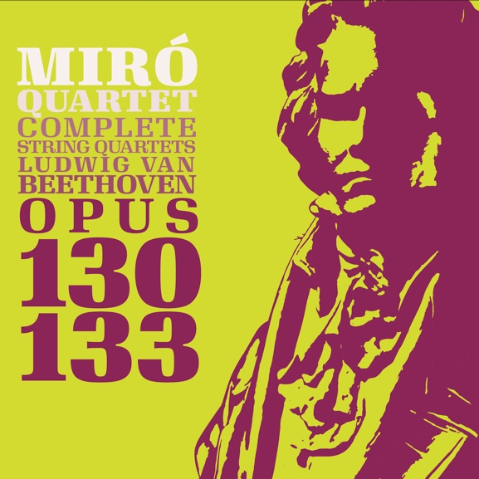

The last two years of Beethoven’s life (1825-1827) were almost completely given over to the writing of string quartets. The monumental work that makes up this recording, Opus 130 and 133, represents the last half of the year 1825. It was written for and dedicated to Prince Nikolai Galitzin (along with the two earlier quartets, Opus 127 and 132). Opus 130 in its original version, with the "Große Fuge" Opus 133 as its finale, represents the pinnacle of Beethoven’s Late Style dramatic language, and as one work it is the longest of Beethoven's quartets clocking in at more than 51 minutes long. It can be said to represent the ultimate expansion of the string quartet to the possible limits of its scope. Indeed, this piece as a whole was completely unprecedented in its time, and remains truly inimitable in its depth and profundity by any compositions in any genre written by anyone since.

The Quartet in B-Flat Major, Opus 130 and the Große Fuge (Grand Fugue), Opus 133 followed the composition of Opus 132 almost immediately, being written in the months from May to September 1825. During most of this time, Beethoven was seriously and dangerously ill, suffering from an intestinal inflammatory disease that alarmed both the patient and his doctor. To make matters worse, the extremely stressful family situation involving Beethoven’s 18-year-old ward Karl was also coming to an explosive head during this time: these ten months were full of personal confrontations, recriminations, mutual personal threats and outright rebellions (by both uncle and nephew). The high pitch of Beethoven’s personal emotions, the rollercoaster of his physical health, and his morbid premonitions of death, were strangely balanced by the sheer positive success the composer was receiving after the premiere of the Ninth Symphony the previous year and the resulting flood of new business offers, as well as the remarkable feeling of almost limitless creative power and inspiration he was experiencing in the afterglow. In such a context, it’s no wonder that this quartet covers the tremendous emotional ground that it does, but it’s even more astonishing that under such circumstances it could be so quickly written and coherently organized.

Opus 130 is an entirely different work from its sibling Galitzin Quartets, Opus 127 and 132 : its wit and charm, and sheer variety of characters it contains reminds us of watching an opera full of ever changing sets and costumes; the constant contrasts keep the listener entertained and guessing from beginning to end. Opus 130 contains Beethoven’s shortest movement of the quartet cycle (movement 2, Presto: 3 minutes), the longest movement (movement 6, the “Große Fuge”: 20 minutes), two folk dances, his own avowed “favorite” slow movement the Cavatina (an operatic aria), an overture, an intermezzo...What doesn’t this composition have up its sleeve? It even has TWO finales!

The story of its two finales does deserve special mention here. Beethoven’s original idea was to crown this third and final Galitzin quartet with a remarkable final movement: the “Große Fuge". This ground-breaking movement is a 20-minute exploration of contrapuntal techniques, dissonance and titanic emotional extremes, but it also thematically and emotionally ties together the various movements of Opus 130 that precede it. It was a revolutionary way to end a string quartet, and Beethoven was very satisfied with his achievement; he sent Galitzin a copy of it in this form and made arrangements with the publishing house Artaria to have it published this way as well.

A year later, in March 1826, the quartet received its first live performance (though it was still yet to be published) by Beethoven’s friends the Schuppanzigh Quartet – and although the piece generally was a success (the Presto and Alla danza tedesca were encored), the Grand Fugue completely mystified the audience, and from all reports, confounded the performers as well, who struggled to play it accurately. This is no surprise as this music sounds contemporary and is challenging to play even today – but the gossip about its difficulty and strangeness began to circulate around Vienna. Alarmed, Beethoven’s publisher grew concerned that he wouldn’t be able to sell the work with the Grand Fugue as the quartet's finale, and enlisted Beethoven’s friends to try to convince him to make a substitution. Artaria offered to pay Beethoven an additional fee and publish the Fugue separately if he would write a different (and easier to play) final movement. After five or six months of back and forth, and the strong persuasion of friends and the exchange of cash, Beethoven agreed to separate the Grand Fugue out as Opus 133, and set to work on writing another, lighter finale.

But this was already a year in the future! At the time of its completion in 1825, it is clear that there existed no doubt in Beethoven’s mind as to the effectiveness of the Fugue as the finale of Opus 130; and frankly it is clear that composing a substitute ending was not his own idea at all. There is no denying that separating out the Fugue in 1826 as its own Opus 133 meant that it was hardly heard again in the century following Beethoven’s death – and consequently it was not until the 20th century that it was recognized as the masterpiece it truly is. On this disc in our recorded cycle of Beethoven Quartets, the Miró Quartet has chosen to present the Opus 130 quartet in its original daring form as conceived by Beethoven, with the Große Fugue as its ending. In our humble opinion, to do otherwise only cheats the audience of the grandness and revolutionary quality of Beethoven’s tremendous 1825 achievement, not only in the context of his time, but in the context of all time.

In any case, the lighter Alternate Finale from 1826 is included as the final track on this recording; to hear the Opus 130 in its later revised and published form, a listener can choose simply to skip from the Cavatina directly to the final track.

Notes by John Largess

